Name ___________________________________________ Date ________________________

Unit 3-1: Introduction to Matter

I. Matter

- Matter is anything that has _____________________________ and __________________________

- Matter also has certain properties (traits or characteristics)

II. Properties

- There are traits or characteristics that can be used to identify matter.

- Can be ___________________________________________________ properties

- Can be ___________________________________________________ properties

III. Physical Properties

a. Characteristics that can be __________________________________without
_____________________________________________________________________________________.

b. Examples:
- ___________________________________________
- Shape
- Texture
- __________________________________________
- Phase or state (solid, liquid, gas)
- Malleability (can be hammered into shapes)
- Solubility (can dissolve in another substance)

IV. Physical Changes

- Occur when one or more of the ___________________________ properties of a substance is changed.

- Examples:
- ____________________________________________________
- Bending copper pipe
- Breaking glass
- Boiling water
- _____________________________________________________

- IMPORTANT: YOU STILL HAVE THE SAME MATERIAL!!

V. Chemical Properties

- How a substance reacts with other substances.

- ____________________________ be observed without _________________________ the _________________________________________ being studied

- Examples:
- Flammability (burning something)
- Reactivity (how a substance reacts when mixed with another substance)

VI. Chemical Changes
- Cause the composition (make-up) of a substance to be different.

- A ____________________________________________is produced with new properties of its own.

- Examples:
- _________________________________________________________
- Acids corroding metals
- Burning sugar
- ________________________________________________________

- A new substance is produced…you do NOT have what you started with

VII. Signs of a Chemical Change

- ______________________________________________ formation
- Light formation
- ______________________________________________ formation
- Color change
- Formation of solid precipitate (materials that can’t be dissolved in a liquid)

VIII. Kinetic Molecular Theory

- Theory that describes that all matter is made of particles that are ____________________________ in motion (______________________________________________________ energy)

- These particles collide with one another but do not stop moving.

- The amount of energy in the particles determines the ___________________________ (phase) of matter.

IX. Solids
- The particles are very close together and cannot move past each other. They just vibrate back and forth in place.
- This causes a solid to have:
- A definite (set) ______________________________________________________
- A definite (set) ______________________________________________________

X. Liquids
- The particles are close together but can slide easily past one another.

- This causes a Liquid to have:
- A definite ________________________________________________________________________
- NO definite shape (liquids take the shape of their container)

XI. Gas
- Particles in a gas are very _________________________________________________and moving freely.

- This causes a gas to have:
- ___________________________________definite shape
- ___________________________________definite volume

XII. Plasma
- State of matter caused when high energy causes the atoms in matter to break apart into charged particles.

- Most common form of matter in the ______________________________ (not earth) found on the ______________________________ and other _________________________________________.

- Naturally occurring on earth in _____________________________________, flames and auroras.

- Produced in fluorescent and____________________________________________________lights.

Unit 3-2 – Phase Changes

I. Phase Changes
- A _______ase change is a _______ysical change that occurs when one phase (state) of matter changes into another.

- Usually occurs when thermal (heat) energy is added or removed
II. Heating Curve
- To show phase changes, a ____________________________________________________is used.

- A heating curve is a graph of _________________________________________________ against
______________________________________________________.

III. Melting

- This occurs when a _________________________ changes to a ___________________________.

- ____________________________________________ in temperature (addition of heat energy) causes particles to move faster and farther apart so the molecules spread out.

IV. Freezing

- A ____________________________ changes to a ________________________________.

- Decrease in temperature (removal of heat energy) causes particles to move slower and closer together.

V. Vaporization: (Evaporation/Boiling)
- A ________________________________ changes to a _______________________________

- ______________________________ in temperature (addition of heat energy) causes particles to move very fast and escape into the atmosphere.
- There are 2 types-evaporation and boiling
i. Evaporation- only takes place on the surface of a liquid
-Example- puddle evaporating on a warm day
ii. Boiling- takes place on the surface and below the liquid.
-Example- boiling water

VI. Condensation
- A _______________________________ changes to a __________________________________.

- Decrease in temperature (removal of heat energy) causes particles to slow down to a point where they are in contact with one another.

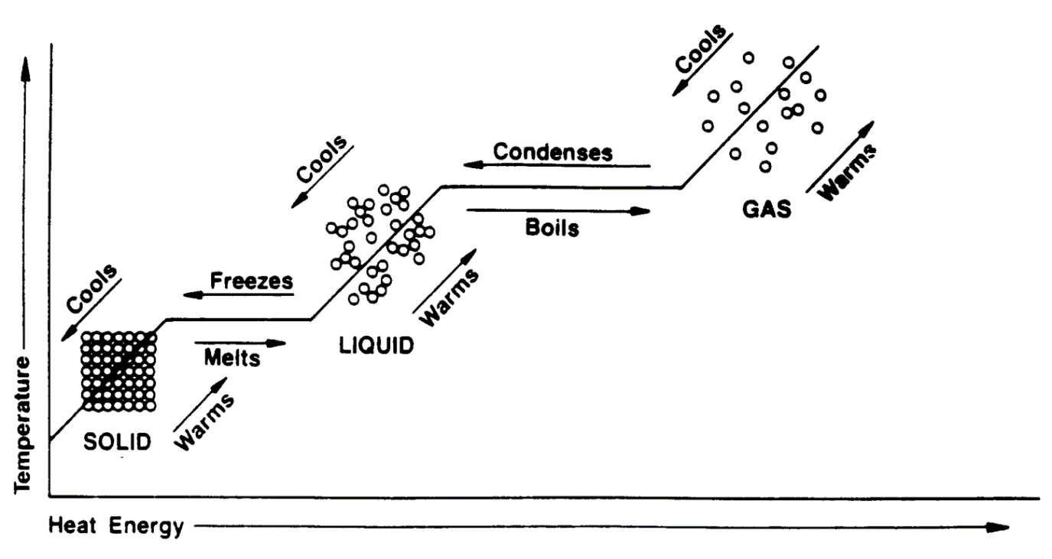

VII. Sublimation
- ______________________________changes DIRECTLY to a _______________________________ (with NO liquid phase in between)

- Examples:
- Dry Ice (frozen Carbon Dioxide)
- Iodine

VIII. Deposition

- ____________________________changes DIRECTLY to a ______________________________ (with NO liquid phase in between)

- Examples:
- Snow-(air to ice)

VIII. Important Temperatures

a. Melting Point – the temperature at which any more additional heat will cause a solid to melt.
- Water (ice cube) 0° Celsius
- Gold 1064 ° Celsius
- Oxygen -218 ° Celsius

b. ________________________________– the temperature at which more heat removal will cause a liquid to change to a solid.
- Water 0° Celsius
- Gold 1064° Celsius

c. _______________________________– the temperature at which any additional heat will cause a liquid to change to a gas.
- Water 100° Celsius (212 F °)
- Gold 2807° Celsius
- Nitrogen -196° Celsius
- Oxygen - 183°Celsius

Some general thoughts….
- As you move from ________________________________, the heat energy increases over time.
- Instead of raising the temperature, the heat energy is used to provide the molecules with more energy to move around.

- As you move from __________________________________, the heat energy decreases (is lost to the environment, or atmosphere) over time.
- Instead, the heat energy is lost because the molecules are becoming more rigid, and they do not need the extra energy for particles to move around

